|  |
| --- |
| **Mrs. Ratnamala Sudhakar Katkar**  **Art Teacher (Assistant Teacher)**  Art Master (University of Mumbai)  Master of Visual Arts (MVA) – Painting (Faculty of Arts) (SNDT University)  Master of Arts (MA) - Faculty of Fine Arts (SNDT University)  Govt. Diploma in Fine Art (Drawing/Painting) (University of Mumbai)  Art Teacher Diploma (A.T.D.) (University of Mumbai)  Handicraft Teacher Training Course (University of Mumbai)  **Email ID:** [ratnamalaskatkar1116@gmail.com](mailto:ratnamalaskatkar1116@gmail.com) |

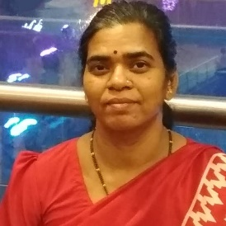

|  |
| --- |
| Mrs. Sejal S. Desai  M.Sc B.Ed  Assistant  Head Mistress  M.K.E.S.English School  Email Id -  [dsejal1976@gmail.com](mailto:dsejal1976@gmail.com#inbox/_blank) |

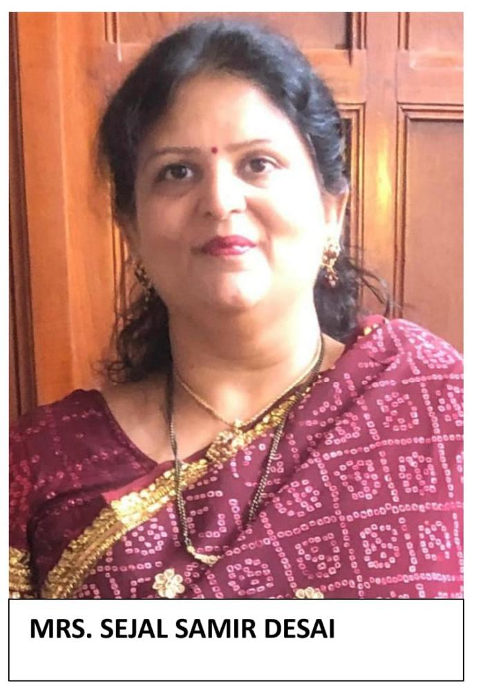

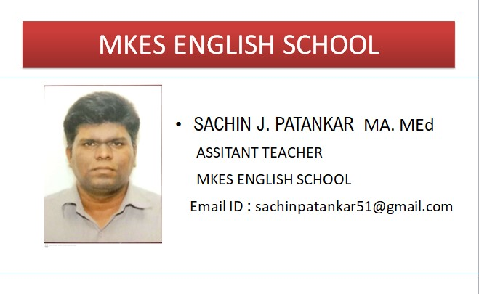

|  |
| --- |
| Mrs. Supriya Shetty  B.Sc.B.Ed.  Assistant teacher  Email [ID:supriyashetty1436@gmail.com](mailto:ID:supriyashetty1436@gmail.com#inbox/_blank) |

